May 20, 2026

Internal workshop | OTAs reverse eng financial data
Invited Ella Waldman Alex Borack Eyal Razi Vadym Padalko Maia Gordon Javier Ibarz
Attachments Internal workshop | OTAs reverse eng financial data
Meeting records Transcript

Summary
The team reviewed technical synchronization challenges and established financial reconciliation protocols for enterprise onboarding and migration data.
Technical Sync and Reconciliation
The team identified widespread OTA content synchronization failures and established that clients must resolve significant financial discrepancies during the migration process. Staff will utilize custom toolkits to manually adjust rent and cleaning fees for enterprise accounts.
Onboarding and Fee Strategies
Participants determined that pre-onboarding account-level fee configurations are necessary to avoid mapping errors. They agreed that manual overrides of reservation data do not persist in channel updates, allowing for temporary data integrity.
Migration Data Management Strategy
The group decided to provide clients with imbalance reports rather than universal migration solutions due to varying financial structures. The primary decision is to prioritize channel data as the source of truth while maintaining manual adjustment workflows for complex tax and fee scenarios.

Rate this Summary: Helpful or Not Helpful

Decisions
We've updated the Decisions section using your feedback.
Let us know what you think: Helpful or Not Helpful

NEEDS FURTHER DISCUSSION
- Default fee configuration approach The team debated implementing default fee configurations or a system-level fee dictionary for new accounts, but requires further discussion to assess risks and implementation details.
- Financial data import discrepancy resolution strategies The team evaluated multiple strategies for handling financial data import discrepancies, such as manual adjustments and new system settings, but requires a follow-up session to determine a finalized approach.

ALIGNED
- Financial mirroring standard confirmed Customer financials are confirmed to require mirroring of their previous PMS data rather than strictly mirroring channel data for migrated accounts.
- Customer liability for data discrepancies The customer is held liable for resolving data discrepancies in cases where the channel is the source of truth but conflicts with their legacy system data.
- Account-level fee mapping workaround The workaround strategy for accounting mapping is confirmed as adding a one-dollar-per-day fee for every fee type at the account level to prevent mapping failures.
- Tax adjustment policy Tax adjustments are prohibited, with channel-provided tax data prioritized to ensure accuracy for legal tax remittance.
- Client responsibility for financial data reconciliation The team aligned that clients bear the responsibility and ownership for ensuring accurate financial data reconciliation on their accounts.

Next steps
- [Javier Ibarz] Review Small Group Notes: Review the document regarding the small group discussion by tomorrow morning.
- [Alex Borack] Provide Listing ID: Provide the listing ID to Javier to facilitate the investigation of syncing issues.
- [Javier Ibarz] Check Listing Access: Verify access permissions for the listing once the identifier is provided.
- [The group] Document PMS Mirroring: Document the business assumption that customers require mirroring legacy system financials rather than mirroring channel data.
- [The group] Review Default Fee Setup: Evaluate whether to implement default fee settings in Guesty for new accounts to prevent unrecognized journal entries.
- [Javier Ibarz] Contact VRBO: Initiate conversation with VRBO support to address incorrect tax data transmission.
- [Alex Borack] Coordinate Meeting: Organize a session with Dario and Henrique to discuss necessary changes to VRBO tax configurations.
- [Alex Borack] Define Host Payout: Establish a formal definition for host payout terminology to support the development of an automated AI solution.
- [Rinat Elimelech] Document Fee Behavior: Document the gap in default fee behavior within reverse mapping for imported reservations.
- [The group] Schedule Followup: Conduct a follow up session next week to continue mapping the behavior of financial data imports across different channels.
- [Ella Waldman] Document Options: Compile a list of potential financial data import solutions including pros and cons for each.

Details
Did the screenshots in this section make your notes better or worse?
- OTA Content Sync Issues: Javier and Alex discuss a technical issue occurring since May 5th, where amenities and photos are failing to push correctly to Online Travel Agencies (OTAs) (00:02:41). Alex confirms this problem affects the entire portfolio across all OTAs rather than being limited to a single client or platform (00:03:43). Javier plans to review this issue with Eigor upon their return from holiday, and Alex agrees to provide specific listing IDs to help facilitate a fix (00:04:33) (00:06:50).
- Office Relocation: Ella, Alex, and Maia engage in a brief discussion regarding the company's planned move to a new building on the border of Tel Aviv and Ramat Gan (00:07:53). The participants note that while traffic in the area may be challenging, utilizing public transportation or bicycles remains a viable commuting option (00:09:30).
- Meeting Agenda and Objectives: Maia and Alex define the goals for the working session, which include analyzing specific use cases for financial reconciliation. The team aims to identify potential friction points in the onboarding process and brainstorm solutions for handling reservation data per channel (00:11:05).
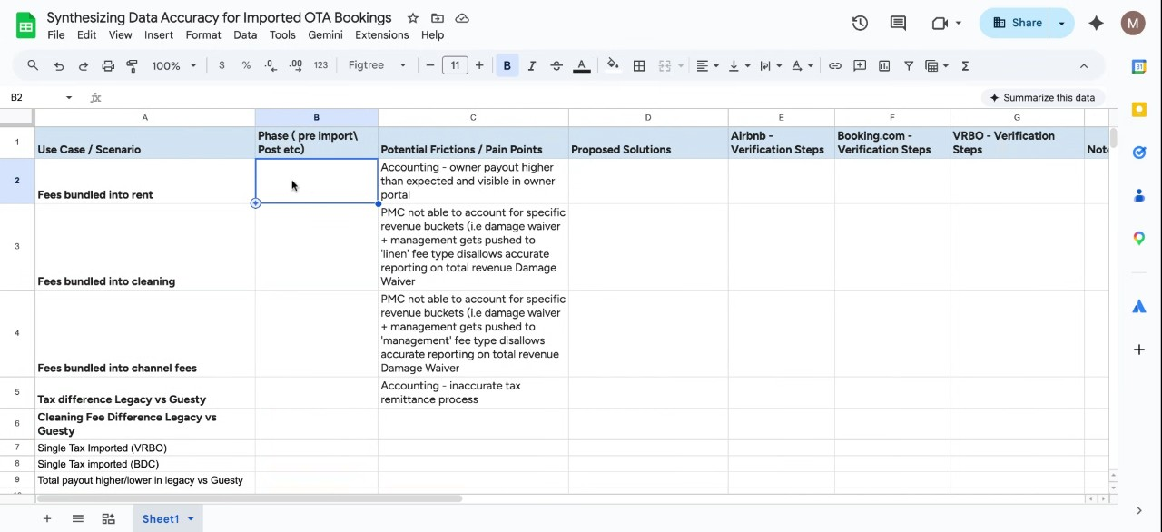
- Financial Reconciliation Assumptions: The group establishes a core assumption that customers expect their imported reservation financials to mirror the records from their previous property management system rather than the raw data imported from the channel (00:16:37). When significant discrepancies exist, the team agrees that it is the customer's responsibility to resolve them, as the staff cannot arbitrarily alter financial data to force a match (00:18:58).
- Handling Rent Discrepancies: Alex explains that when rent amounts differ between a legacy system and Guesty, the standard practice is to mirror the source system. Alex emphasizes that it is critical to guide users during implementation so they understand that the realization date must align with their specific revenue recognition practices (00:20:55).
- Cleaning Fee Imbalances: The discussion addresses challenges with cleaning fees, particularly when legacy providers like Vicasa utilize dynamic, length-of-stay, or seasonality-based pricing that does not translate to the channel. Javier notes that while conditional fees are being applied to accommodation fares, current logic does not accommodate similar bundling for cleaning fees (00:22:14) (00:25:23). Ella expresses concern about potential gaps in meeting client expectations for length-of-stay pricing and suggests further investigation into this development (00:26:28).
- Toolkit for Invoice Adjustments: Alex demonstrates the use of a custom toolkit that cross-references source files with a comprehensive list of fee types (00:29:51). This tool enables the team to manually adjust rent and cleaning fees and add necessary additional fees to ensure reservation folios accurately reflect the expected totals (00:30:52).
- Pre-Onboarding Fee Setup Strategy: To avoid mapping errors and ensure accounting accuracy, Ella and Alex discuss the strategy of setting up all potential fee types at the account level during the pre-onboarding phase, even if a nominal value is used (00:35:23). Vadym suggests that a more efficient, long-term approach could be to apply an "imported" flag to reservations on the backend, allowing the system to handle accounting logic differently rather than relying on manual workarounds (00:39:21).
- Alignment of Pricing Data: Javier highlights the importance of ensuring that pricing data from reservation reconciliation remains fully aligned with data sent from a business-to-consumer perspective. Javier emphasizes that the team must understand how the channel calculates these final amounts to ensure consistency across the platform (00:44:48).
- Data Override Assumptions: Alex challenges the previous assumption that manual adjustments to reservation data in Guesty will be automatically reverted by future channel updates (00:46:49). Based on testing conducted over the last two months, Alex reports that their manual manipulations have not been overridden by subsequent channel syncs, which prevents the need for repetitive work (00:47:46).
- Tax Discrepancies and Remittance: The group discusses the complexity of handling multiple tax types imported from Airbnb, where identifying a total imbalance is possible, but applying that adjustment to the specific tax item is difficult (00:54:40) (00:56:52). Vadym recommends avoiding manual adjustments to tax items and instead prioritizing channel data, noting that the property manager is responsible for remitting the correct funds to local authorities based on accurate records (00:55:46).
- Enterprise Support Expectations: Alex Borack and Ella Waldman clarify that their current efforts are a white-glove service intended for enterprise clients rather than small and medium-sized businesses. They acknowledge that while they do not perform manual fixes for all users, the scale of enterprise clients necessitates their direct intervention to resolve data discrepancies that those clients cannot handle themselves (00:57:52).
- Vacation Rentals By Owner Tax Data Discrepancies: Alex Borack and Javier Ibarz discuss a recurring issue where Vacation Rentals By Owner sends tax data as a single lump sum rather than broken-out tax types. The team currently resolves this by manually zeroing out the Vacation Rentals By Owner tax and re-adding the correct tax types to align with user expectations (00:59:03) (01:01:43). Javier Ibarz notes that this stems from previous property management system integration issues, and while feedback has been shared with the channel, the team identifies a need to escalate this further to ensure data is sent in a usable format (01:00:13).
- Client Compliance and Reporting Requests: Ella Waldman and Alex Borack address specific requests from the client KM regarding owner statements and tax reporting (01:03:47). The client is requesting that taxes remitted by channels on fees be added to owner statements, which Alex Borack describes as a request driven by a desire for specific guest tracking and adherence to Hawaii regulations. The team expresses skepticism regarding these requirements, noting that their current accounting module is already compliant, and they identify a need to align the client’s expectations with the system's capabilities (01:04:55).
- Host Payout Mismatches: Ella Waldman and Javier Ibarz discuss data discrepancies regarding total host payouts when migrating from legacy systems (01:05:51). Because different clients use different financial structures, the team concludes they cannot rely on a universal solution (01:07:49). They decide that the best approach is to provide clients with a report identifying material imbalances, while keeping the responsibility for adjustments with the client (01:05:51) (01:09:26).
- Channel-Specific Import Variations: Vadym Padalko and Alex Borack note that reservation imports behave differently across channels, such as Airbnb versus Vacation Rentals By Owner, requiring unique scripts to handle varying levels of data observability. Alex Borack emphasizes that while Airbnb serves as the primary test case due to its prevalence, the underlying data issues are consistent across any channel where reservations are imported (01:11:21).
- Account Fee Configuration: Ella Waldman and Rinat Elimelech discuss the risk of manual onboarding errors when setting up additional fees. They observe that current onboarding processes sometimes bypass proper mapping by creating default placeholder fees, which can lead to issues with reverse mapping later (01:15:23). The team suggests implementing a more robust, default configuration rule upon account creation to prevent these issues (01:14:09).
- Fees Bundled Into Rent: Alex Borack, Rinat Elimelech, and Ella Waldman examine the challenge of fees that are bundled into rent within legacy data (01:17:37). They conclude that applying a universal rule is not feasible given that fee configurations change over time (01:19:36). The current workaround, which they plan to continue using for now, involves adjusting the rent and using a toolkit to manually add the correct invoice items to the folio based on a legacy report (01:20:46).
- Proposed Automated Migration Solution: Ella Waldman and Alex Borack discuss the concept of a "snapshot" feature that would allow clients to define settings and apply them to specific reservations (01:23:15). This would allow the system to recalculate financial distributions rather than relying on manual, override-prone adjustments (01:24:35). Javier Ibarz suggests that this could be handled by importing reservations with minimal data and then layering the financial breakdown afterward (01:26:13).
- Source of Truth and Channel Logic: The group deliberates on whether the system should strictly treat channel data as the absolute source of truth or allow for more flexible imports (01:29:35). Javier Ibarz proposes three potential options for importing financial data: sticking to the current channel-data-driven approach, generating breakdowns based on internal settings, or importing with one line item and allowing the property manager to provide the financial breakdown (01:30:36).
- Booking.com and Vacation Rentals By Owner Technical Behaviors: Javier Ibarz and Maia Gordon review specific technical constraints for Booking.com and Vacation Rentals By Owner. They note that while Vacation Rentals By Owner supports bundled fees in certain configurations, other property management systems often fail to utilize these features correctly, resulting in incorrect financial data (01:33:28) (01:35:37). Specifically, for Booking.com in Australia and New Zealand, taxes applied to bundled rent amounts often result in incorrect figures, forcing the team to manually manipulate the data to ensure reporting accuracy (01:37:13). The team agrees to meet again next week to continue mapping these scenarios (01:39:17).

You should review Gemini's notes to make sure they're accurate. Get tips and learn how Gemini takes notes
How is the quality of these specific notes? Take a short survey to let us know your feedback, including how helpful the notes were for your needs.

